Points to make notes

- Make sure all headings are appropriately tagged as H1, H2, H3, H4 as in the word document
- Create a jump list so people can easily navigate to the appropriate sections, given the length of the content.
- Make sure the jump list is movable so that, as you scroll, it is easy to click and go to the right location.

- Instead of Accordions, I like the way you have used read more, read less eg

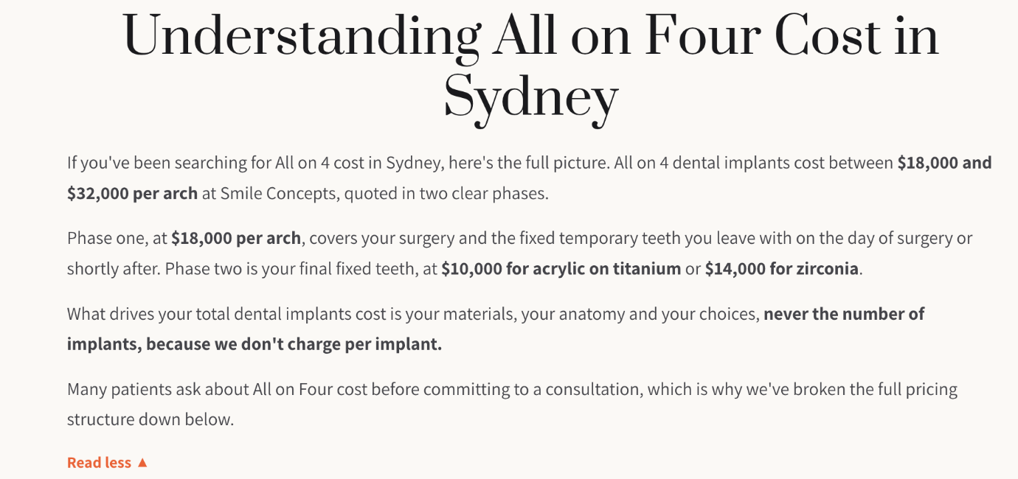

- Please section the whole page into the H2 sections I have done. Ie 2 columns, as Vik will explain.

- Please rearrange all the questions based on the word document

- Use exact copy and paste, as it has taken me time to clean the grammar and syntax.

Scroll Screen (right at the top)

All on 4 Dental Implants Sydney

Before and Afters

Real Stories Real Smiles

General Info
General Info

Prosthetics (Teeth)
All on 4 Implant Surgery

Process

COST

Your investment: Trasnsparent Two phase pricing

CALCULATOR

Cost related questions

Longevity
Risks

Meet Your Full arch Dentists

Why patients choose us

Our Practice

Our Accreditations and Professional Affiliations

FAQs
FAQs

Book A Consultation

Footer

For us to develop later.

Develop supporting pages on cost, All on 4 vs All on 6, dentures, individual implants, materials, lifespan, bone loss, revision, gum disease and recovery. Link them contextually to this service page once published; do not add links to pages that do not exist.

